Knowledge Graph

SAP HANA Cloud Graph engine

SAP BTP – lot of services and capabilities to create Gen AI workflows and applications
Foundation models – LLM provided by open AI / GPT (build by SAP / Partners)
HANA DB - for storing data in different formats, allows GenAI application to retrieve data for RAG patterns (DB AI engine / Vector engine / KG engine / Data management
Life cycle management of AI – few services for AI lifecycle management
AI related services – process structured and unstructured data in form of documents
Joule – Chat Bot for client
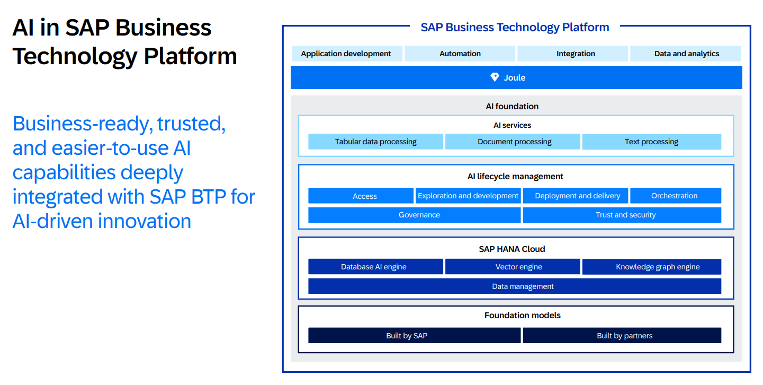

SAP Hana cloud provides couple of capabilities for gen AI workflow and applications
1] Spatial engine – Handles spatial data types like coordinates, maps, geometries. Used in location-based services, geospatial analytics, etc.
2] Full type search – stored in tables that are relational type
3] Document stores – built-in, NoSQL-style storage engine that enables you to store, query, and manipulate JSON documents natively within the database. It’s ideal for handling semi-structured or unstructured data, and works well alongside relational tables
4] Vector engine – Store and query high-dimensional numeric vectors efficiently. This is essential for modern applications such as: Semantic search using embeddings (e.g., text, images), Recommendation engines, Anomaly detection, Natural language processing (NLP) using vector embeddings
5] Graph engine - A specialized engine for storing and querying graph data (nodes, edges). A Property graph is a type of data model used for representing complex, highly interconnected data and it's supported via Graph Engine.
6] Text search - is a powerful capability that allows for full-text indexing, searching, and natural language processing (NLP) on textual data. It supports fuzzy matching, stemming, ranking, linguistic analysis, and more—making it ideal for search-driven apps, chatbots, and intelligent document processing.
7] Machine Learning - is deeply integrated into the platform, enabling users to build, train, and run ML models directly inside the database, close to the data—eliminating the need for data movement and boosting performance and scalability.
8] Hierarchies - provide a way to model and query data with parent-child relationships, which is common in business scenarios like organizational structures, product categories, bill of materials (BOM), or chart of accounts.
9] Knowledge graph – organize connected data in form of triples and consume it in AI workflow
It is a powerful way to represent, connect, and query structured, semi-structured, and unstructured data by using graph-based models that enable semantic understanding.
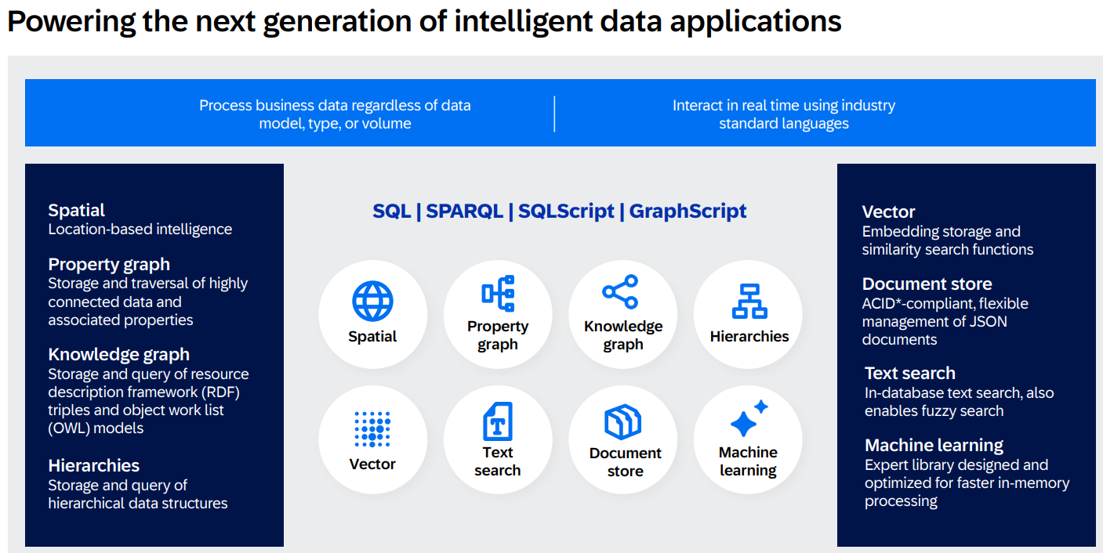

Knowledge graph

Knowledge graphs are a form of representing structured information in the form of entities and relationships. Entities must have relationships with each other.
They capture these connected data in a way that machines can process and provide understanding about this information
Also provides ways to query this relationship and infer new data from the representation
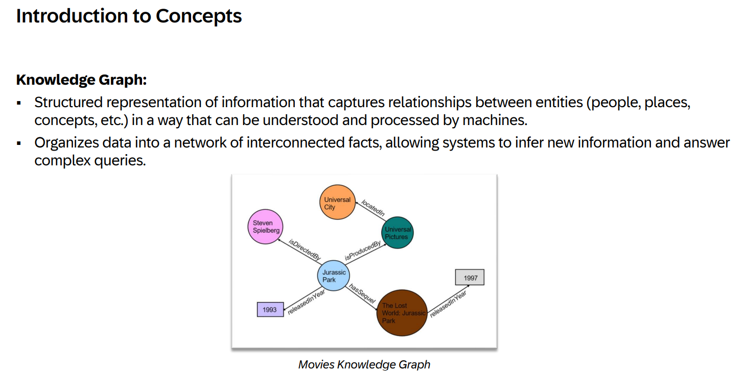
Triples

Data structures follow node -> edge -> node pattern (Subject -> Predicate -> Object) triples
RDF is a framework that essentially describes how triples are described and organized
RDF -> Triple store (stores graph in atomic triples) in HANA cloud
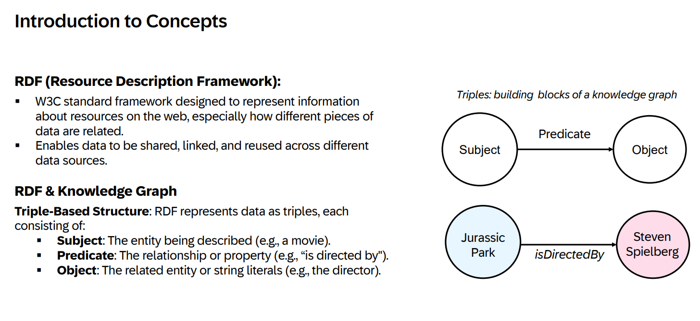
S-P-O data structure is used to store data in HANA cloud
Triple structure is very flexible - Integrate data from different domains forming triples, new data
RDF graph - Specific schema enhancement is not needed where column is added newly. RDF additional triple will be added directly.
Data Integration – keys that represent entities should be unique (URIs to represent entities)
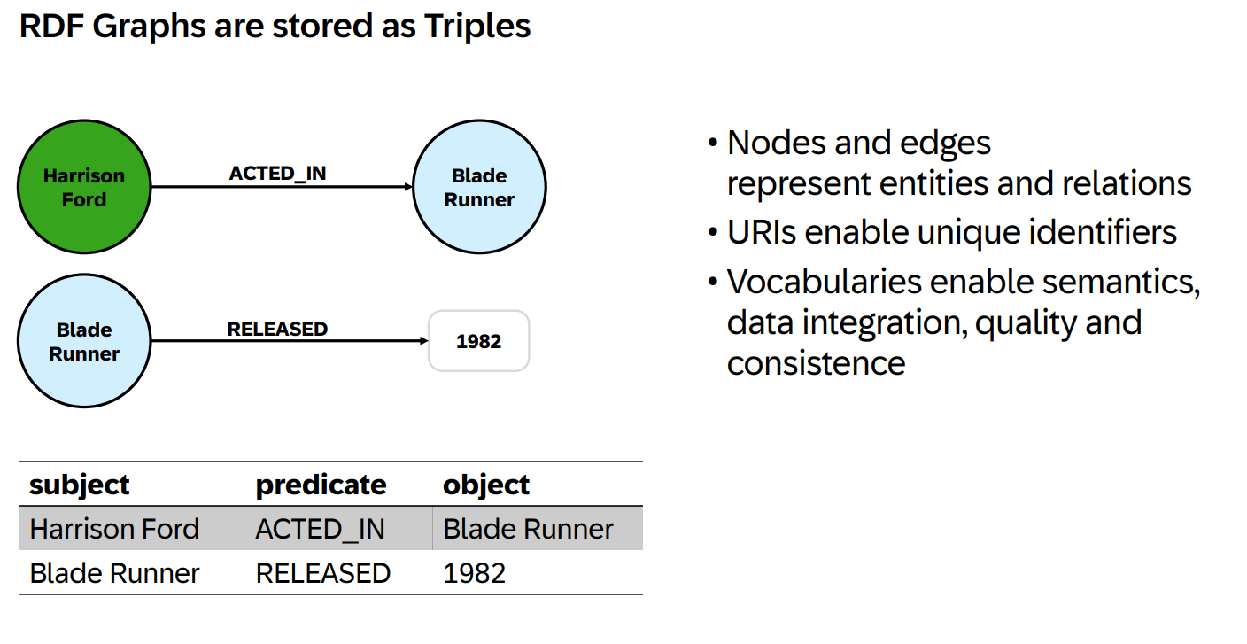
URIS

URIs are used to identify entities that are quite long with names same prefixes to make it unique (wikidata)
Public standard vocabulary can also be used to standardize semantics (foaf – friend of a friend)
Multi language literals that can be language dependent by using suffix (@en)
Depict data types beside string literals (1982 is of type year)

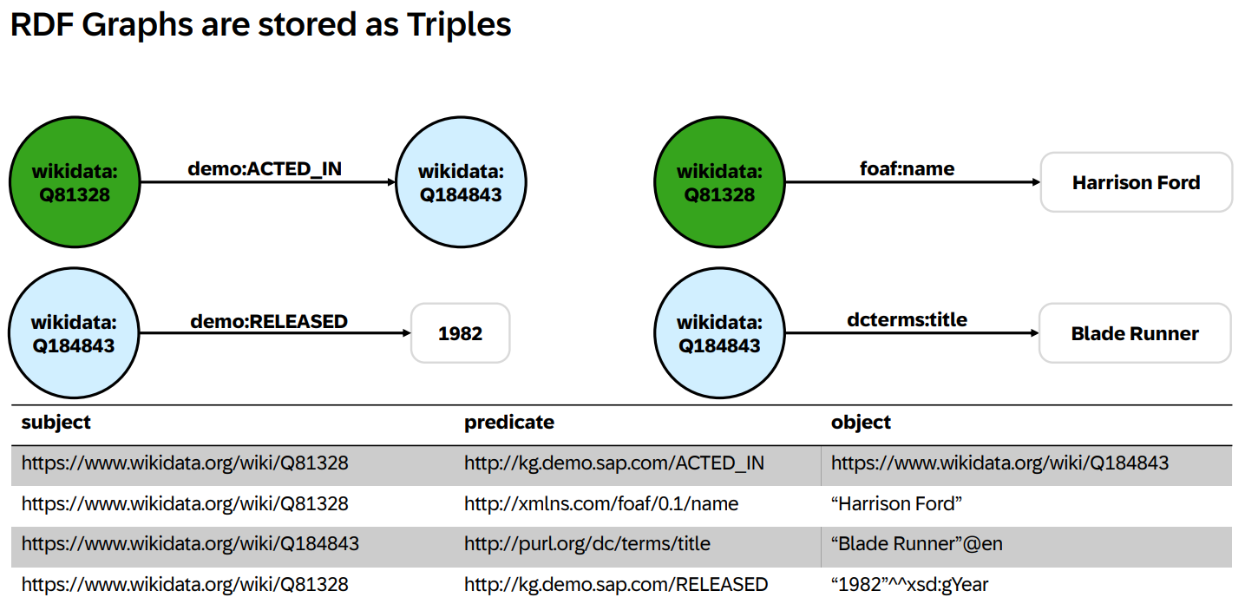

Query language – SPARQL (looks a bit like SQL)
SPARQL – pattern matching query language which are a list of triples
Select clause – not referring to columns, selecting set of variables that are used in where clause where we define a pattern which is search for in the data
Where clause
From clause
Variable – movie
Entity – type movie
Variable - Title of the movie
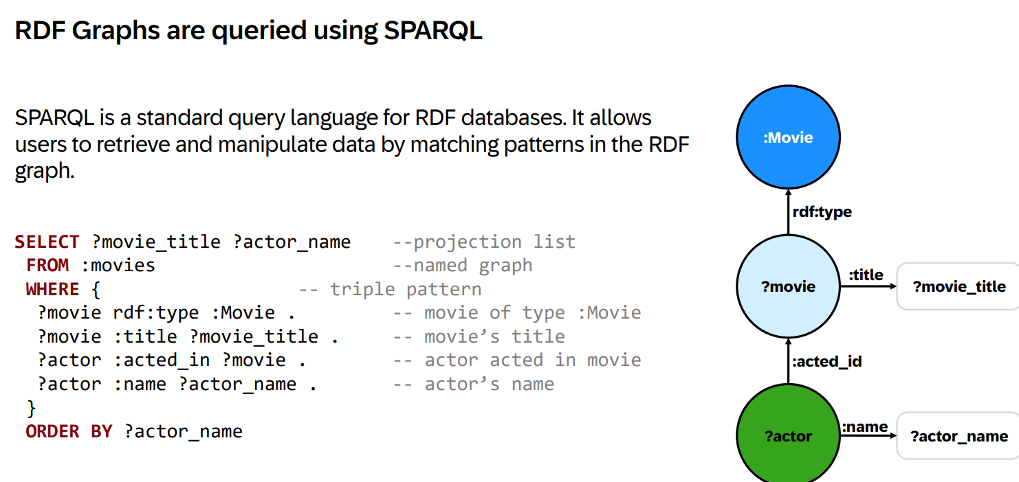

QRC1 release

SAP Hana cloud Q1 release, where KG has two main components
1] RDF triple store – like other stores (json or table), RDF data types and import / export relational data formats
2] SPARQL query engine – not only select queries but also others including manipulate data, multiple response formats.
KG is Integral part of SAP Hana cloud, there are specific ways to leverage KG Sql interoperability and SPARQL, SQL interoperability
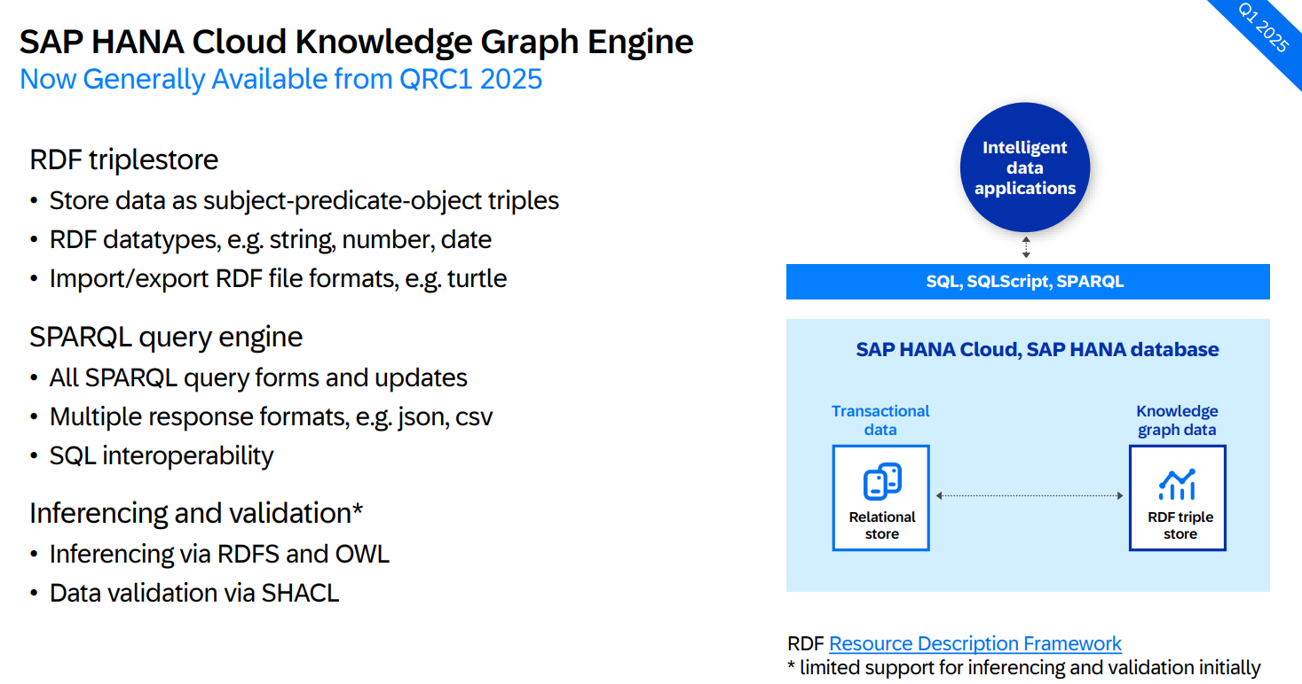

Interoperability

SAP Hana cloud is a SQL DB, access to SPARQL or KG is handled by a builder procedure and build in table function
SPARQL_EXECUTE – procedure handles all type of query and returns the response in json format
SPARQL_TABLE – allows to run read / select queries and return a table with sql datatypes
Table function as sub queries in more complex sql queries
TF is one form of interoperability between SQL and SPARQL
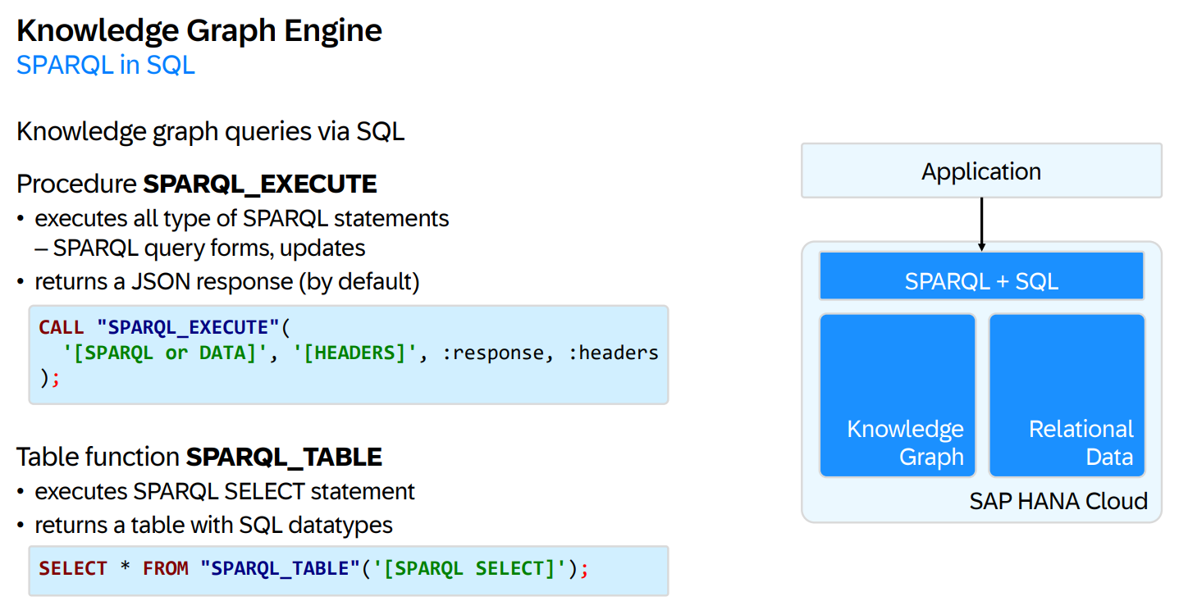

There is also a SQL table function as part of SPARQL, SPARQL queries can have SQL queries inside it with SQL table function to retrieve data from relational data and include it in KG data
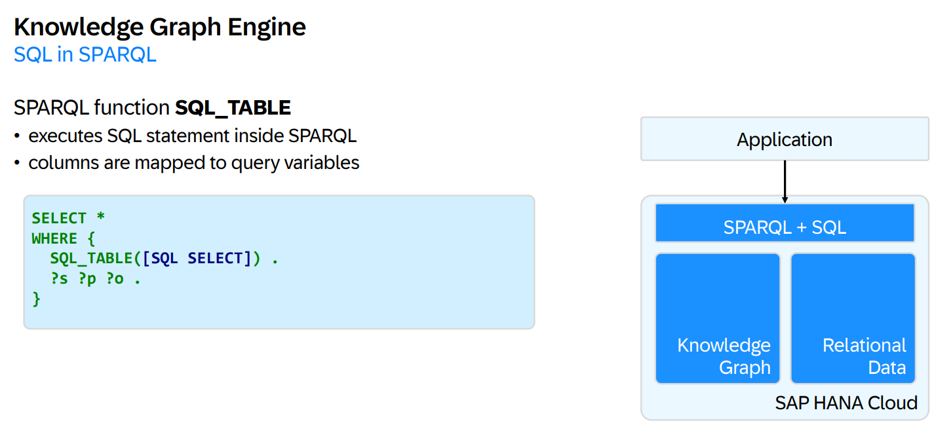
Ontologies

Sets KG apart from standard relational processing is Ontologies.
On top of KG data graph, data can be modeled and defined with higher level relationships (taxonomies of classes or arbitrary relationships between classes)
Harrison – entity of type Actor
Class Actor is a subclass of a class person
Ontology on top of data graph, allows to infer new data
Ontology also uses semantic relationships in semantic queries
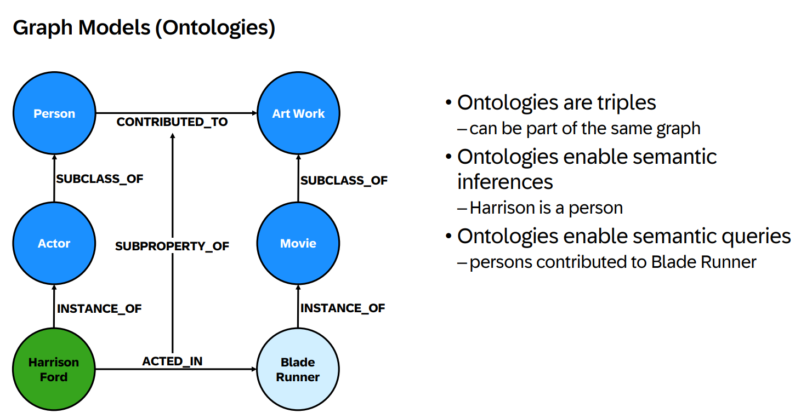

KG engine as part of HANA cloud

How to switch on KG engine which is not active by default
While instantiating SAP Hana cloud instance in BTP, below configuration is to be made to add KG engine as well
Triple store is to be selected which includes KG engine
Minimum Memory needed – 48 GB
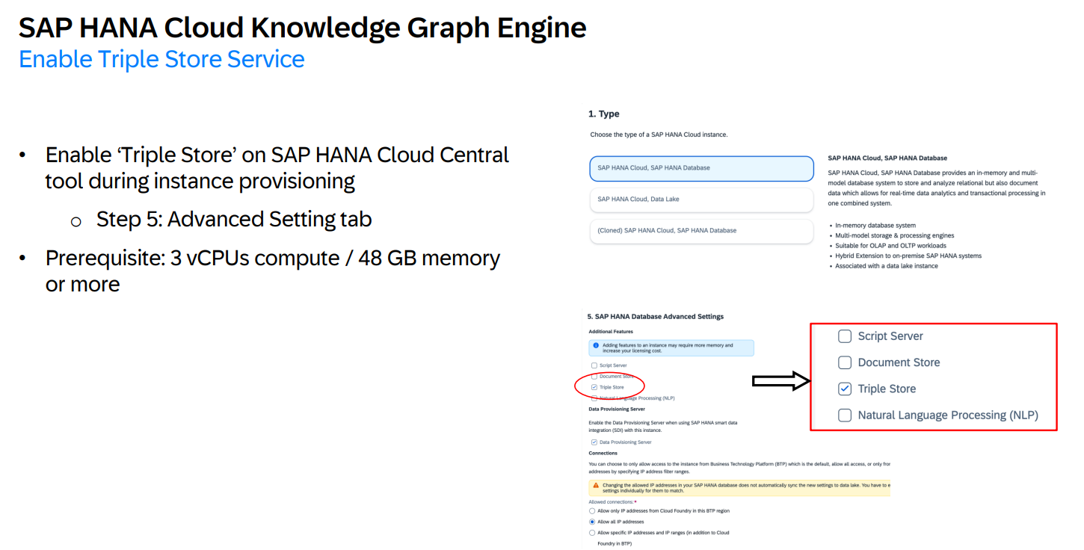
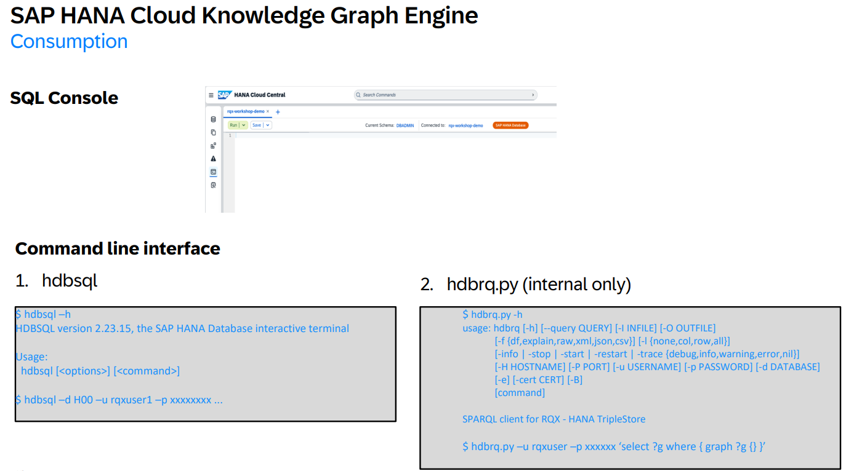
RAG

Retrieval Augmented Generation
Very common pattern to improve GenAI workflows and applications
In a nutshell, RAG is about retrieving additional context that is relevant for end user question, to provide the context to LLM like GPT, to come up with sound and grounded answer to the question
GenAI chatbot is used to ask questions, where RAG pattern retrieves context by using vector storage or sematic search
Vector / semantic – common tech of how we run retrieval of context in GenAI workflows (unstructured)
Structured data – Different ways to run RAG patterns
Convert end user question to a SQL statement and retrieval of relational data to be fed to downstream LLM to come up with answer
KG is a powerful way to retrieve context, pattern is converting Natural language and user query into SPARQL query, retrieve relevant spots of KG and these data is triggered by triples to hand it over to LLM

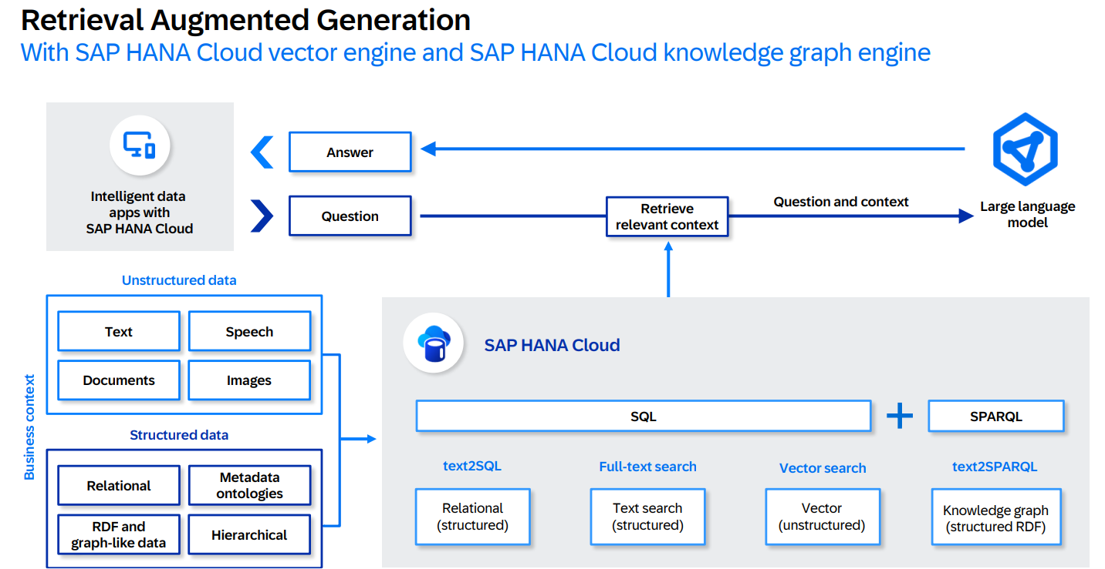

RAG text embeddings vs KG

RAG using text embeddings
Source data – documents / natural language text sometimes provides chucking in form of longer documents and get chunked up in smaller pieces and these chunks generates text embedding vector from the text
Retrieval in RAG uses vector-based search (semantic search), get couple of chunks relevant to end use query and hand it to LLM and provides answer to end user for reference
LLM reasoning or extracting facts for doc to generate response
RAG using Knowledge graphs
Source data is structured data that is well described in forms of entities and relations that are from tables or different domains
LLM to extract triples from text and hence stored in KG
Text to SPARQL conversion is made in different ways
LLM aggregating triples to come up with generated response
Text embedding is used in narrow queries with limited documents or chunks
KG allows to run queries that require information from a lot of different sources, allows to run broadly complex queries
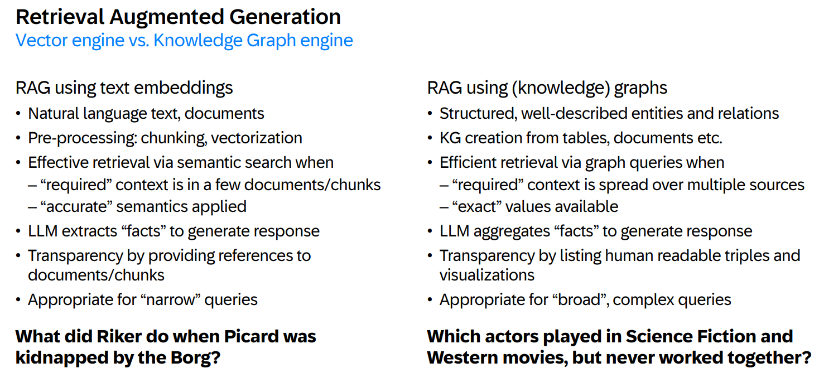
Graph generation and retrieval

Two approaches come together in certain scenarios
KG from structured sources with high precisions
Extra unstructured content that provides additional information about the subject
LLM can also be used to extract facts from this unstructured content in the form of triples and integrate the information into the existing KG
Semantic search by text embeddings and structured retrieval form KG in form of SPARQL queries

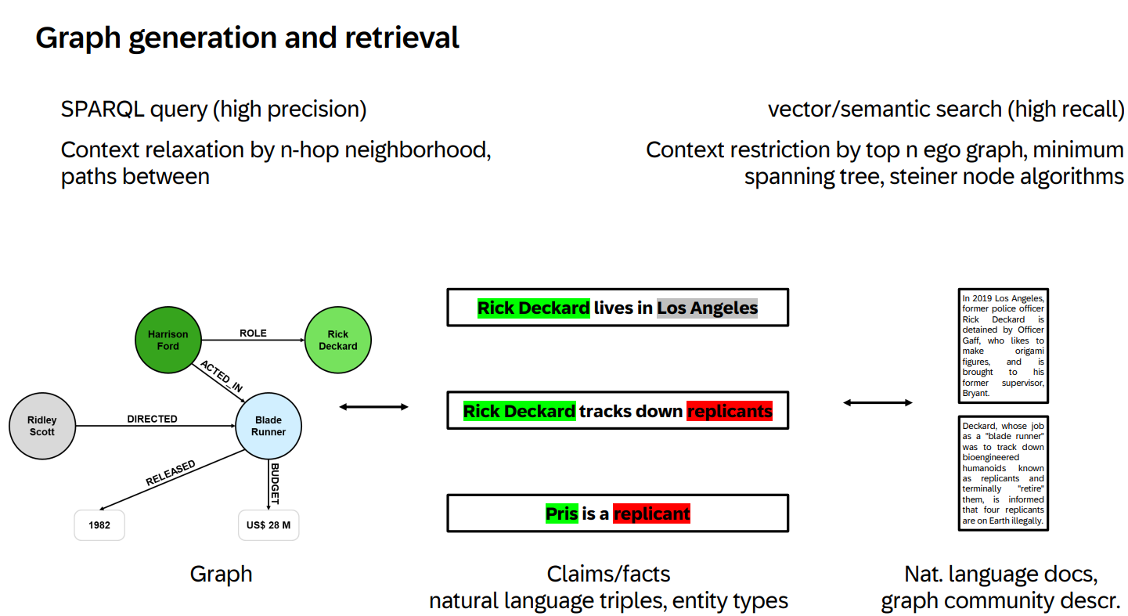

Demo

Application built to showcase certain Hana cloud capabilities
Set of movie data with movie plot information in the form of table (structured) that are relational data stored in Hana
Ran the movie data in text embedding model to retrieve embeddings by semantic search for movie plot information
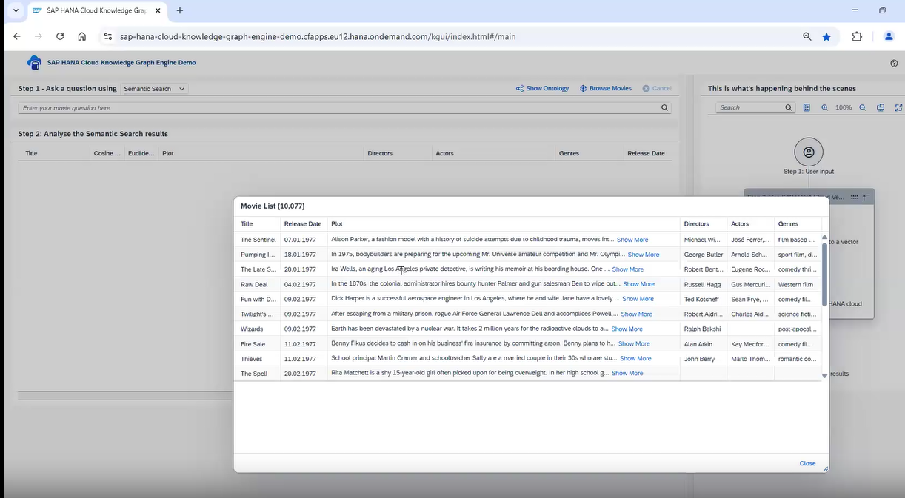
Plain granular semantic search
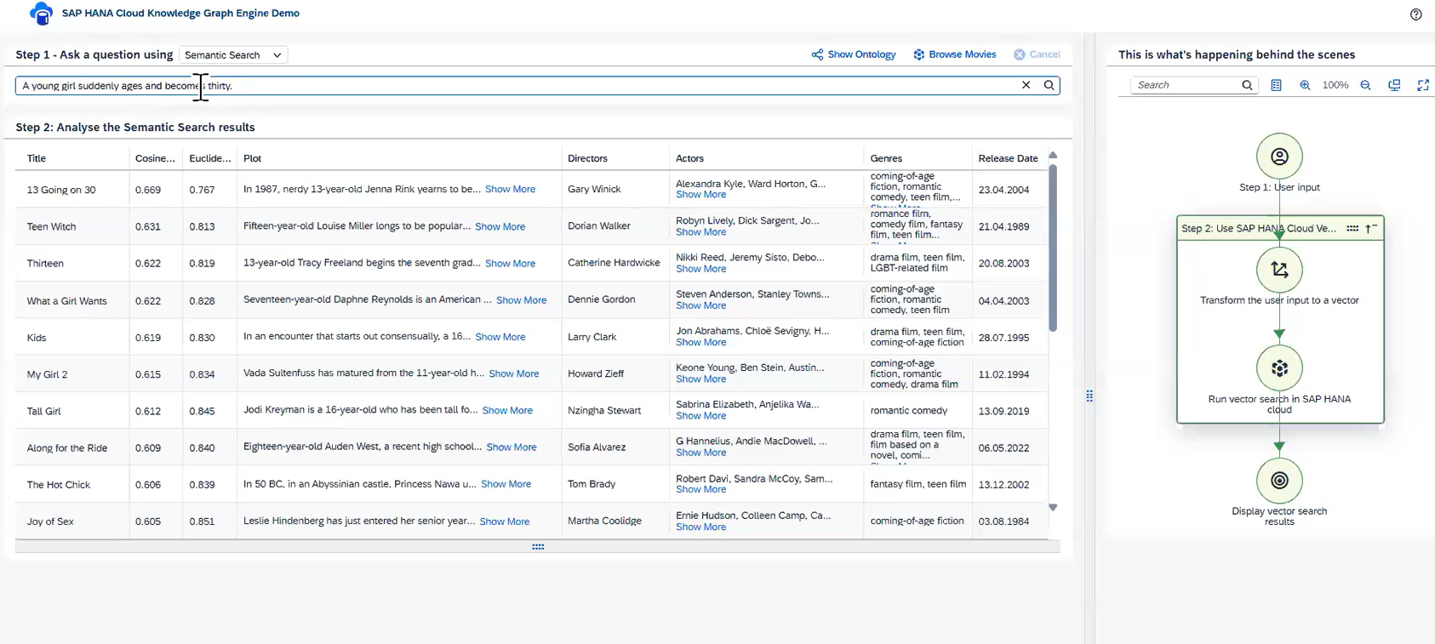
BG process
User input -> Transformed the input to vector -> Text embedding vector is used to run the semantic search in HANA cloud -> result is displayed (cosine similarity)
This is the plain search used in RAG patterns
For more complex queries, vector search might not be possible as there will be no semantics available
We switch to data retrieval from KG
Class level data has been stored in KG in the form of entities
KG based retrieval, LLM to translate end user query to SPARQL query and run it against KG to get a tabular result
Results can also be explored in visual manner
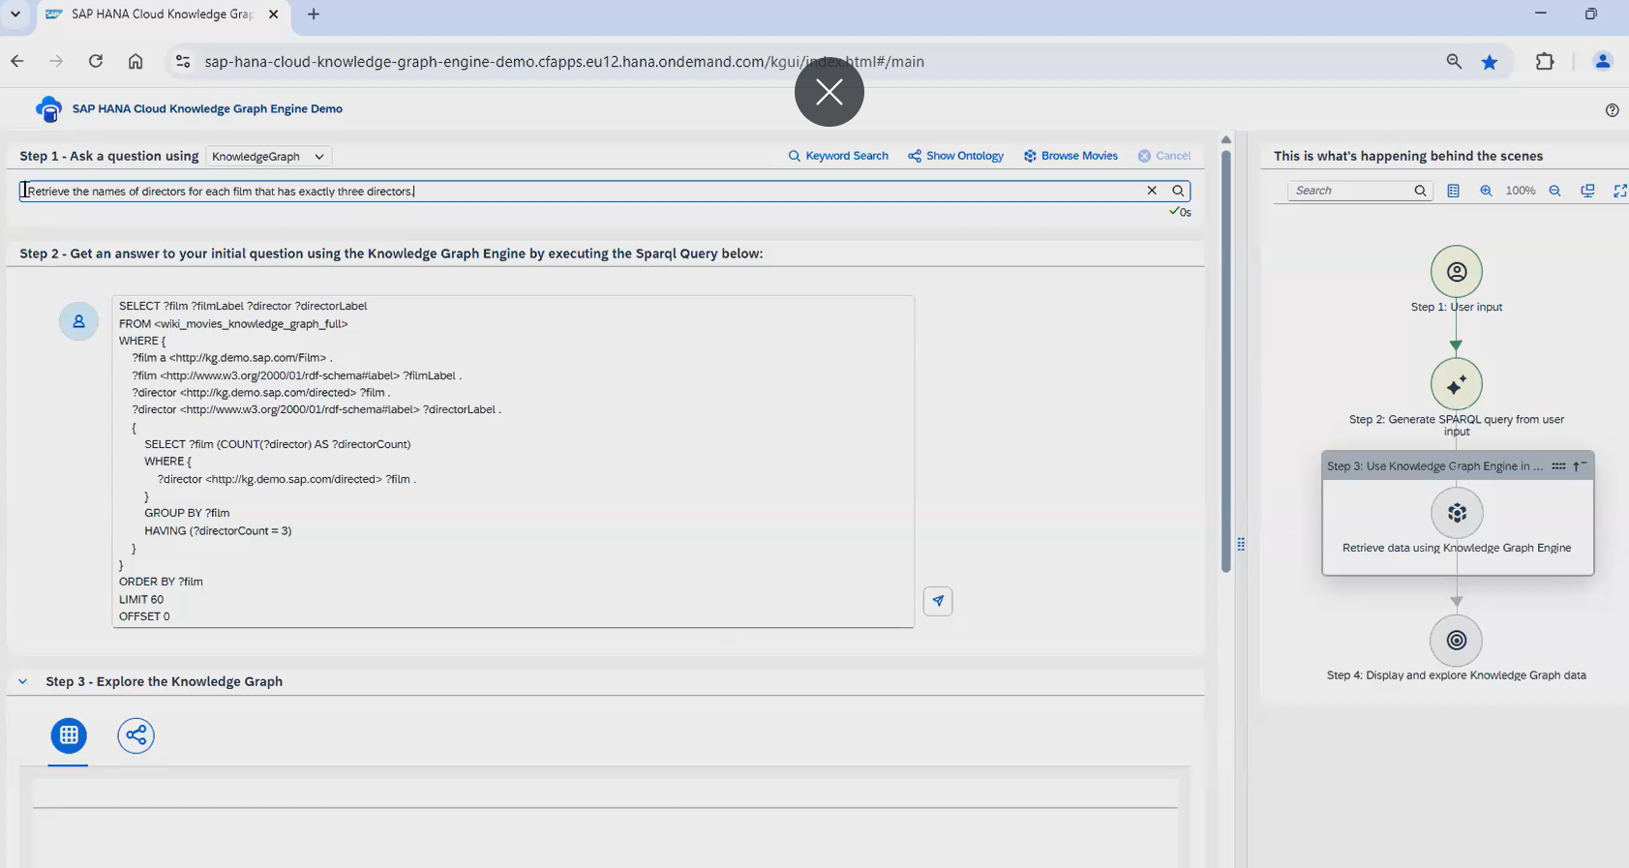
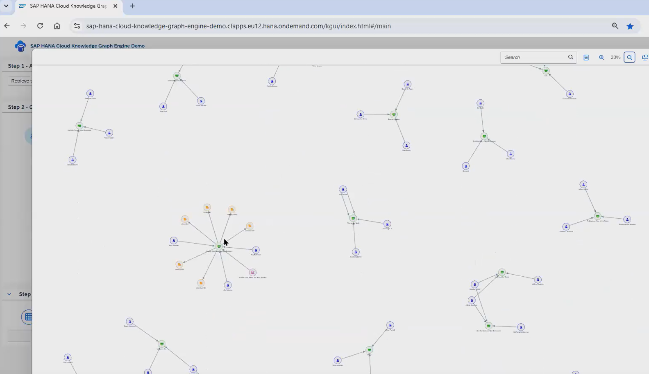

Use case patterns
GenAI and RAG were primary modulations to introduce KG engine to retrieve more structured semantically rich data sets
Linked Open Data projects work with same tech – triple stores
RDF and SPARQL query language used for processing
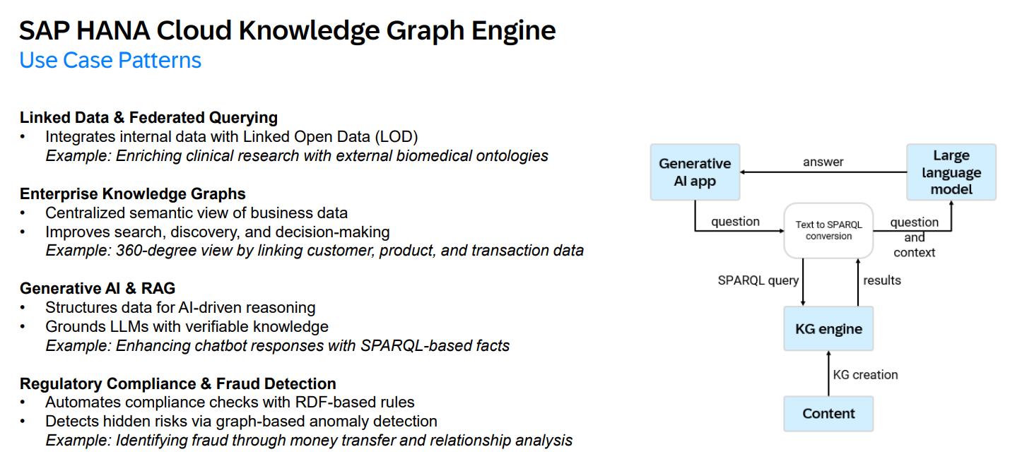
Value proposition
Enhancing AI workflows and applications when it comes to semantic generation of structured data
KG engine allows you to run complex queries and derive insights from collective data
Integrate data from different sources (Enterprise / third party / public linked by LOD)
KG allows to add extra layer of semantics ontologies on top of data
Integral part of SAP Hana cloud, interoperability with SQL and SPARQL (mix relational and KG information)
Multi model capabilities – Spatial / Vector / Json and graphs

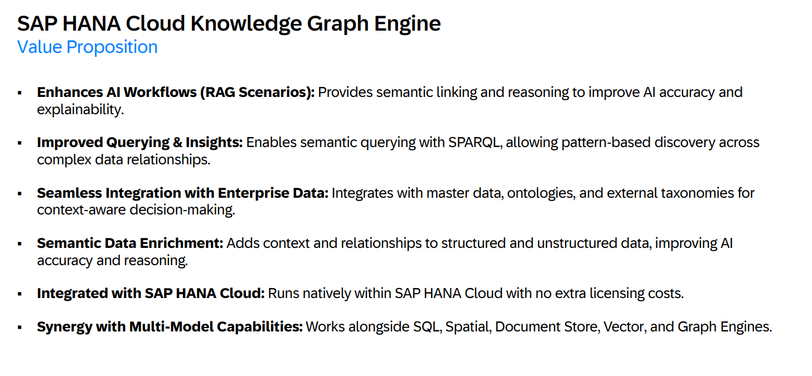
Future Roadmap
Langchain plugin – library in python and javascript allows to create GenAI workflows and applications. Convert property graphs to.
